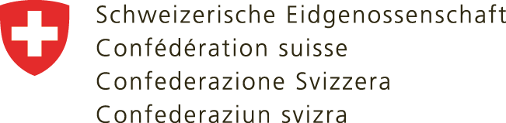 | Embassy of Switzerland to South Africa, Botswana,  Eswatini, Lesotho, Mauritius and Namibia  Regional Consular Centre Southern Africa
Consular Days Durban 2021 – Passport/ID application request

Please return this form (1 form per person) by 27.04.2021 by E-mail to southernafrica@eda.admin.ch

Surname
Name
Date of Birth (dd/mm/yyyy)
Civil Status / Date | Single Divorced  Married Widow  Since:
Address
Phone number
E-mail address
Height in cm
Order | Passport Passport & ID  Adults ZAR 2’510.00 Adults ZAR 2’800.00  Children ZAR 1’170.00 Children ZAR 1’460.00  ID  Adults ZAR 1’250.00 (prices are subject to change)  Children ZAR 670.00  Details and current prices will be communicated with the appointment confirmation.  An electronic bank transfer must be made in advance, to the bank account of the Embassy of Switzerland in Pretoria.  Please make sure that the Consular Centre receives the full amount. The client must pay bank fees.
Remarks/ notes

